caAERS Release 2

Use Case Document
Version 2.1

DOCUMENT REVISION HISTORY
Version Number | Date | Description
1.0 | April 2004 | COH completed Release 1 of caAERS
2.0 | January 19, 2007 | First iteration of Release 2 completed by Semantic Bits, et al
2.1 | January 23, 2007 | Sean Whitaker, Update template and revise use cases
2.2 | February 28, 2007 | SW, incorporate Niket’s feedback and changes from It 2
2.3 | April 9, 2007 | Changes from Iteration 2 of Construction Phase

Table of Content

1 Introduction 3
1.1 Project Overview 3
1.2 Document Overview 3
1.3 Related Documents 3
2 Actors and Goals 4
3 Use Cases 5
1 Module 1: AE Data Capture 5
1.1 Create Study for AE Data Entry 5
1.2 Create Subject 7
1.3 Assign Subject to a Study 9
1.4 Study Abstraction – Sponsors, Committees and Organizations 10
1.5 Create AE 11
1.6 AE Data Collection 14
1.7 Search AE Entry 16
1.8 Create Candidate AE Entry 16
1.9 Configure Institution AE Notification Triggers 17
1.10 Configure Sponsor Level AE Notification Triggers 20
1.11 Configure Study Level AE Notification Triggers 20
1.12 Configure Messages, Timing and Escalation Rules for Notifications 20
1.13 Create Solicited AE 21
1.14 Add New Version of Existing Study 21
2 Module 2: Interface to Local Clinical Trial Databases 22
2.1 Import of Related Patient and Study Data Pre-Existing in a CT Database System 22
2.2 Export of AE Information into Local CT Databases for Future Aggregation and Analysis 22
3 Module 3: Mapping to Vocabularies and Coding Systems 23
3.1 Mapping to Vocabularies and Coding Systems 23
4 Module 4: Report Generation and Submission to External Agencies 24
4.1 Create Report Formats 24
4.2 Generate Report Form 24
4 Overall Requirements 25
4.1 Requirements Prioritization 25
5 Data Definitions 25
6 Sign Off 26
6.1 Approval 26

Introduction

Project Overview
The purpose of this project is to develop and deploy an adverse event reporting system that is nationally scalable with a robust architecture to meet the needs of the caBIG™ Community. The caAERS requirements, data model, and use cases developed during Release 1 will be the foundation for this effort. The Developer Team will execute Elaboration, Construction and Transition Phase activities for this project. The project will be carried out using the Agile Unified Process Framework, emphasizing continuous integration, testing, and risk management. Two Adopters, Wake Forest and The Mayo Clinic have been assigned and funded by caBIG™ and their input and collaboration throughout this project is critical to the timely release of functional software. The Developer Team will work closely with these Adopters, any additional adopters identified by NCICB, and the Adverse Events Special Interest Group to ensure the deliverables of this project will meet the needs of the caBIG™ Community.
The Developer Team will develop the cancer Adverse Event Reporting System (caAERS) that will utilize a standards-based architecture and provide tools for integrating data from existing clinical and research systems. This project cycle of the cancer Adverse Event Reporting System will provide four modules, each providing a different set of functionality: Adverse Event Data Capture Tool, Integration of the Adverse Event Data Capture Tool and Local Clinical Databases, Vocabulary Mapping Service, and External Agency Reporting.

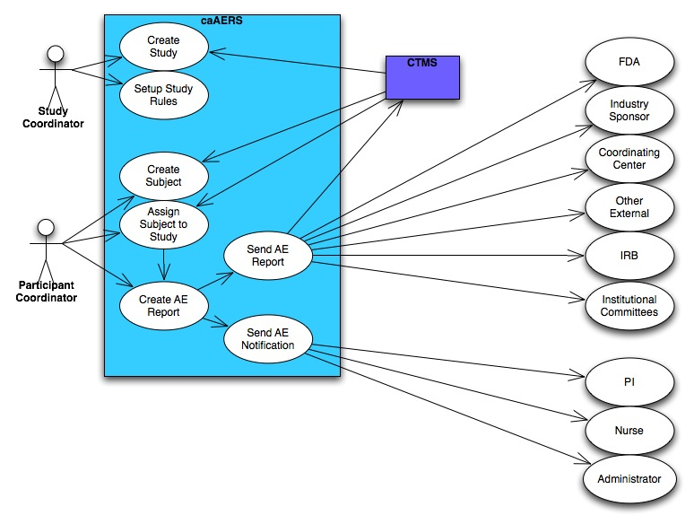

Document Overview
This document presents design-level use cases organized by the four modules currently under development. This document defines a use case as a sequence of actions that an actor (usually a person, but perhaps an external entity, such as another system) performs within a system to achieve a particular goal.

Related Documents
Document Name | Version | Location
caAERS Vision and Scope | V 1.0 | https://gforge.nci.nih.gov/plugins/scmsvn/viewcvs.php/docs/Management/caAERS%20Vision%20and%20Scope.doc?root=caaersappdev&view=log
caAERS System Requirements Specifications Doc | V 1.0 | https://gforge.nci.nih.gov/plugins/scmsvn/viewcvs.php/docs/SRS/?root=caaersappdev

Actors and Goals
These Roles reflect how the functionality of the caAERS application will be partitioned.

Roles
System Administrator  (SysAd) | - Creates new user accounts  - Manages user access to the application  - Approves and manages user registration process  - Grants users to a role within the application  - Generates new passwords when passwords are lost
Study Coordinator (SC) | - Enters Study Protocol abstraction data  - Creates triggers for determining SAEs and reporting requirements  - Configures notification and reporting recipients
Participant Coordinator  (PC) | - Enters Participant data  - Creates AE Reports

Use Cases

Module 1: AE Data Capture

The following Use Cases address the Adverse Event Data Capture Tool, a web-based user interface for manual entry of data surrounding an Adverse Event. Based on information entered through a web interface, the system captures the severity of the adverse event and provides some workflow for identifying and capturing decisions necessary for further reporting.

Create Study for AE Data Entry

Brief Description
Before AE data can be captured for a given Subject and Study, the Study must exist within the caAERS system. In this Use Case, a Study Coordinator (SC) creates an entry in the caAERS system for an existing Study in order to capture AE data. (Note: Module 2 Use Case 2.1 represents the caAERS function for abstracting Study AE data from an existing CTMS system.)

Primary Actor
Study Coordinator (SC)

Preconditions
1. The Study does not already exist in the system.

Basic Flow of Events

- The SC has logged into the system and indicates he/she wants to create a new Study.
- The system displays a page that allows the SC to create a Study.
- The SC enters and saves the data (see Data Item below).
- The system checks for duplicate Study (e.g., match on Site PI, Sponsor name and Sponsor Study ID).
  - If duplicate is found:
    - Alert SC of a possible duplicate study and display details of the duplicate.
    - SC views a page with the possible duplicate study information.
    - SC may choose the following actions:
      - Change study data to modify entered data and continue. (Note: Site PI, Sponsor Name or Sponsor Study ID must be changed or a duplicate warning with occur again)
      - Cancel to the main menu page without creating the new study.
  - If no duplicate is found, continue.
- The system assigns a unique identifier to the Study, not visible to the user.
- The system displays a confirmation to the SC upon successful Study creation.

Postconditions

- Study information is stored in the system.
- Unique system Study ID assigned.
- Confirmation of Study creation is displayed.

Special Requirements

Data Item:
Data Item | Notes/Validation Rule
Site Principal Investigator | Coded element. Required
Long study title | Required
Short study title | Optional
Primary sponsor name | From LOV Required
Primary sponsor study identification number | Not Required
Primary sponsor study version | Not Required
Primary sponsor study version date | Required  mm/dd/yyyy- forced format upon typing or calendar
Agents and Devices | Not Required capture any number of these as well as IND or IDE #.and holder of this number
Local Study ID | Should be able to capture additional IDs as required by the institution
Phase of Study | Added to facilitate triggers, Coded, Required
PrimarySponsorID | Added to facilitate Sponsor Level triggers, Required
Sites | In multi-site trials, this describes which sites are involved in performing the trial.
Study Diseases | Not required, capture any number of these.

Notes
- Data about the Study either never changes or changes infrequently.
- The actor is able to exit the function at any time.
- The system will store the following information for audit purposes:
  - User information related to the registered study.
  - The caAERS institution that registered the study.
  - Date and time of activity.
- The combination of data items that trigger a duplicate warning are:
  - Site Principal Investigator name
  - Primary sponsor name
  - Primary sponsor Study ID number
- caAERS will provide the ability to edit this data.
- In data items, are version information and Review Date actually required?

Create Subject

Brief Description
Before AE data can be captured for a given Subject and Study, the Subject must exist within the caAERS system. In this Use Case, a Participant Coordinator (PC) creates an entry in the caAERS system for an existing subject in order to enable AE data capture.

Primary Actor
Participant Coordinator (PC)

Preconditions

- The Subject is qualified and enrolled in the study. (caAERS does not manage eligibility or enrollment workflow.)
- The Subject does not already exist in the system.

Basic Flow of Events

- The PC selects Create Subject.
- The PC enters data about the Subject and submits it (see Data table below).
- The system checks for duplicate Subject.
  - If duplicate is found:
    - System displays duplicate data
    - PC decides to:
      - Modify data
      - Cancel Subject creation
  - If no duplicate is found, continue.
- The system displays a confirmation to the PC of successfully creating a Subject.

Postconditions
- Subject data is stored in the system.

- The PC is presented with a confirmation of Subject creation.
- The PC is presented with a link to assign a Subject to a Study (see Use Case 1.3).

Special Requirements

Data
Data Item | Notes/Validation Rule
Subject Identifier | At least one is required. The system will allow for any number of these to be specified and will capture both the name of the identifier as well as its value.
Subject Name
First Name/Initial | Required
Middle Initial | Not Required
Last Name/Initial | Required
Date of Birth | Mm/dd/yyyy, forced format or calendar, Required
Gender | Coded, Required
Race | Coded, Not required
Ethnicity | Coded element, Not required

Notes
- Confirm with VCDE regarding CDEs to use as codelist standards for Gender, Race, and Ethnicity fields.

- Subject data either never changes or changes infrequently.
- The SC can exit out of the function at any time.
- Data is not overwritten. A new record is created. Only the most recent update is displayed.
- An audit trail is provided.
- Must be able to view and edit subject data.
Unresolved

  - May need use case to merge/reconcile/link institutional patient records if they are mistakenly entered as duplicates.

Assign Subject to a Study

Brief Description
Subjects must be assigned to a Study before AE data can be abstracted. In this Use Case, the Participant Coordinator (PC) assigns a Subject to a Study.

Primary Actor
Participant Coordinator (PC)

Preconditions

- Subject must exist in caAERS system.
- Study must exist in caAERS system.

Basic Flow of Events

Option 1:
1. PC creates a Subject or selects an existing Subject.
2. PC selects a Study and Site.
3. PC saves the assignment of the Subject to the Study.

Option 2:
1. PC selects a Study and Site.
2. PC selects an existing Subject.
3. PC enters StudySubject ID and submits the assignment of the Subject to the Study.

- The System will generate an alert if a duplicate assignment is found.
  - PC will be able to:
    - Cancel assignment
    - Select a different Study
    - Select a different Subject

Postconditions
1. Subject assignment to a study is recorded in the caAERS system.

Special Requirements
Data
Data Element | Notes/Validation
StudySubjectID | Should support multiple institutional and sponsor-assigned identifiers

Study Abstraction – Sponsors, Committees and Organizations

Brief Description
This use case links sponsors, committees and organizations (entered as “Organizations” into caAERS) that are important to the management of the Study as they relate to the recording and reporting of AEs. The Study Coordinator will be able to enter/update information about these entities. The basic course of action is to link an Organization to the protocol by adding the Organization to a collection associated with the protocol. The SC will then decide whether is concerned with all AE Reports entered into the system or only for those Reports which involve a particular Agent or Device.

Primary Actor
Study Coordinator (SC)

Preconditions
- The Study exists in the system.
- SC has entered all appropriate institutional values for the coded elements: Sponsor, Committees and Organizations into the system.
- SC has found the desired Study.

Basic Flow of Events

- The SC navigates to the Study abstraction screen – Sponsors, Committees, and Organizations.
- The SC searches for the desired protocol (Use Case 1.13).
- The SC selects a Sponsor, Committee, or Organization and associates it with the Study.
- The SC enters the appropriate data regarding this association. (See Data table)
- The system stores the information.

Postconditions
- Sponsors, committees and/or organizations have been associated with the Study.

Special Requirements
Data Items
Data Item | AERS Class (Types)
Entity | Sponsor, Committee, Funding Agency, External Regulatory Agency, Multi-Center Consortium
Entity Name
EntityID (e.g. sponsor ID)

NOTES:
Detailed information about the Sponsor, Committee, or Organization will be entered and edited through an administrative interface. It will not be reentered here. The Actions taken with respect to these entities will be described by the Rulesets.

Create AE Report

Brief Description
The Participant Coordinator (PC) creates a new AE Report for a given Subject assigned to a Study. This report is manually entered into caAERS so that the system can determine whether the report should be treated as routine or expedited and which entities should receive copies of the report.
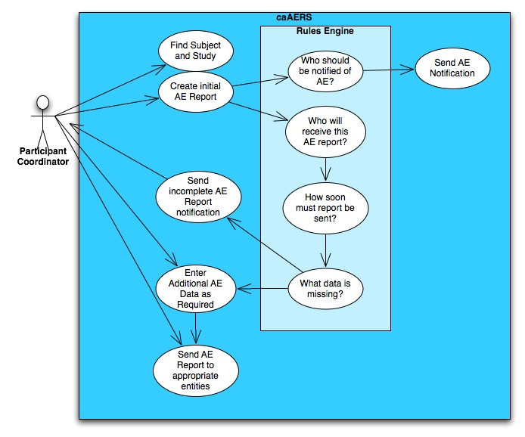

Primary Actor
Participant Coordinator (PC)

Preconditions

1. The Study has been created.
2. The Subject has been created and assigned to the Study.

Basic Flow of Events

- The PC searches for and selects a Subject on which to record one or more AEs. If the Subject is linked to multiple Studies, the applicable Study must also be selected.
- The PC selects option to create a new AE Report.
- The initial data screen is presented with Study and Subject identified.
- PC prompted to input the required data to create an AE Report.
  - If Report is a duplicate:
    - PC may continue to submit duplicate report.
    - PC may change values and submit again.
    - PC may cancel report.
  - If Report is not a duplicate, data is submitted to system.
- PC receives a confirmation window and can choose to ‘EXIT’ to default to the main menu (see Note 4 below) OR can choose to ‘CONTINUE DATA COLLECTION’ (see Use Case 1.6).

Postconditions
- PC will have created an AE Report for a Subject assigned to a Study.
- Configured triggers are invoked.
- System prepared for subsequent AE data collection.
- The AE Report is in state “pending.”

Special Requirements

Data Item
Data Item | Type | Notes/Validation Rules
AE Detection Date | Required for duplicate check | Def: date recorded in source documentation or by pt. or family caregiver or date of lab test.
Start Date of Primary AE | Required
End Date | Not required, only entered if applicable
MedDRA Code | Required if AE category and term not provided.
Category | Required if MedDRA Code not provided. | CTCAE
CTC Version | Required if MedDRA Code not provided. | CTCAE v2.0/3.0
Term | Required if MedDRA Code not provided. | Also provide an “Other, Specify ____” text box
Grade | Required | Only appropriate grades for each term should be available for selection.
Expectedness | “Requiredness” dictated by configured institution, sponsor and study triggers | Timing and who of reporting dictated by configured institution, sponsor and study triggers
Attribution | “Requiredness” dictated by configured institution, sponsor and study triggers | Timing of reporting dictated by configured institution, sponsor and study triggers
Hospitalization | “Requiredness” dictated by configured institution, sponsor and study triggers | DCP or CTEP definitions may be utilized
Treating Physician | Required

Notes
- Pre-existing conditions system derived from previous AE records
- Dose Limiting toxicity derived study triggers; dose limiting management not covered in initial phase of caAERS
- Business rule for determining a duplicate AE: a) match on CTC AE Category and Term or MedDRA Code and if detection range is within 30 days of an existing AE for the subject
- If the actor chooses to ‘EXIT’ on basic Course step 9, then caAERS will notify the user to complete the data collection within a certain time frame. (This time frame has not been determined yet.)

AE Data Collection

Brief Description
A Participant Coordinator (PC) enters additional data about an AE which already exists in the system. The “requiredness” of data elements is dynamically determined based upon configured triggers and reporting needs.
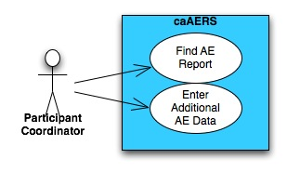

Primary Actor
Participant Coordinator (PC)

Preconditions
1. The AE Report already exists in the system.
2. Notification triggers have been setup.

Basic Flow of Events

- The PC selects option to search for AE Report entries by Study Participant and Protocol. (Use Case 1.7). Protocol-specific codes should show up first.
- The PC selects the desired AE Report.
- caAERS displays the AE Report data entry screen with current data.
- The PC completes dynamically generated data collection (Use Case 4.2) form which comprises the core data elements required for the indicated reporting agencies as determined by the triggers. PLEASE SEE SAE Form Elements spreadsheet for the identification of elements comprising the core data set as determined by requirements from all external reporting agencies
- The PC submits data.

Postconditions
- After successful completion of this use case, the SC will have saved edits to an existing AE for a Study Participant linked to an existing protocol.
- Time stamp of last saved edits with User ID are readily viewable. An audit log of updates is available.
- Reporting triggers and notifications are invoked and updated as data collection occurs.
- Once data collection has been completed the AE moves from a Pending to the Completed state.

Special Requirements
See Data form

Notes
- It was emphasized that we need to design a good interface in caAERS AE Data Collection for CTC and MedDRA coding. There are two principle difficulties: (1) length of some of the descriptions. Some descriptions are very long and there is no clean way to show them without wrapping the text or using tool tips, and (2) sheer number of codes. This interface should be prototyped early to allow for plenty of feedback and rework. Easy search/selection of CTC and MedDRA codes (as well as mappings btwn them) is critical.
- Detection Date is not required for non-SAEs Cycle number - use as an optional field? (Mayo captures a field called "evaluation date")
- Start and Stop dates may need to be optional or required depending on triggers/rules. More investigation needed here.

Search AE Entry

Brief Description

Primary Actor

Secondary Actors

Preconditions

Basic Flow of Events

Postconditions

Special Requirements

Create Candidate AE Entry

Brief Description

Primary Actor

Secondary Actors

Preconditions

Basic Flow of Events

Postconditions

Special Requirements

Create AE Notification and Report Ruleset

Brief Description
This use case will describe the creation of AE notification and report Rulesets. A Study Coordinator (SC) will create a Ruleset in the administrative interface and designate a Ruleset as being a Study, Organization, or Site Ruleset. The Rulesets are invoked when an AE Report is created and stopped when all Notifications and Reports are completed or the notification time period has passed.

Primary Actor
Study Coordinator (SC)

Preconditions
The appropriate Study, Organization, and Site have already been created.

Basic Flow of Events
1. SC selects option to create a new Ruleset.
2. SC chooses a title for the Ruleset.

3.
SC chooses from drop-down list whether the Ruleset is a Study, Organization, or Site level Ruleset.
4. SC creates a new rule.
5. SC creates a condition consisting of an attribute from an AE Report, an operator, and a value. (See chart below for possible attributes of a condition.)
6. SC repeats step 5 as necessary to complete the rule. Each condition has an AND relationship to the other conditions within the rule. (See chart below for conditions.)
7. SC selects the agenda that will be executed if the conditions of the rule are satisfied.
8. SC repeats steps 4 thru 7 for each rule in the Ruleset.
9. If Ruleset is a Study-level Ruleset, SC will select the appropriate Study with which to associate the Ruleset.
10. If Ruleset is an Organization-level Ruleset, SC will select the appropriate Organization with which to associate the Ruleset.
11. If Ruleset is a Site-level Ruleset, SC will select the appropriate Site with which to associate the Ruleset.

Postconditions
The SC has created a Ruleset that will be run at the creation of the appropriate AE Reports.

Special Requirements
Data Item
Data Item | Type
Ruleset Name | Required
Ruleset Type | Required, Study, Organization, or Site
Report Attributes: | One selected for each condition of a rule
Grade | Not Required
Hospitalization | Not Required
Expectedness | Not Required
Phase | Not Required
Attribution | Not Required. Must be selectable in terms of particular agents or devices being used on the trial.
AE Term | Not Required.
Operators | Required, =, <, >, <=, >=, <>
Actions | Required. Defined in Administrative Interface

NOTES:
1. We now need to create the Use Cases for the Administrative Interface.
2. This Use Case makes 1.10 and 1.11 obsolete. Delete these for next iteration.

Configure Sponsor Level AE Notification Triggers

Brief Description

Primary Actor

Secondary Actors

Preconditions

Basic Flow of Events

Postconditions

Special Requirements

Configure Study Level AE Notification Triggers

Brief Description

Primary Actor

Secondary Actors

Preconditions

Basic Flow of Events

Postconditions

Special Requirements

Configure Messages, Timing and Escalation Rules for Notifications

Brief Description

Primary Actor

Secondary Actors

Preconditions

Basic Flow of Events

Postconditions

Special Requirements

Create Solicited AE

Brief Description

Primary Actor

Secondary Actors

Preconditions

Basic Flow of Events

Postconditions

Special Requirements

Add New Version of Existing Study

Brief Description

Primary Actor

Secondary Actors

Preconditions

Basic Flow of Events

Postconditions

Special Requirements

Module 2: Interface to Local Clinical Trial Databases

This component will provide a standards-based API for integrating the Adverse Event Data Capture tool with an adopting institution’s clinical trials management database. This may include a webservices or caGrid interface, depending on the touch points required.

Import of Related Patient and Study Data Pre-Existing in a CT Database System

Brief Description

Primary Actor

Secondary Actors

Preconditions

Basic Flow of Events

Postconditions

Special Requirements

Export of AE Information into Local CT Databases for Future Aggregation and Analysis

Brief Description

Primary Actor

Secondary Actors

Preconditions

Basic Flow of Events

Postconditions

Special Requirements

Module 3: Mapping to Vocabularies and Coding Systems

The reference architecture and data services will utilize the mappings created in other projects and available through the caDSR to facilitate customized reports and forms based on the user’s vocabulary preferences.

Mapping to Vocabularies and Coding Systems

Brief Description

Primary Actor

Secondary Actors

Preconditions

Basic Flow of Events

Postconditions

Special Requirements

Module 4: Report Generation and Submission to External Agencies

caAERS will provide interfaces and methods for the messaging of AEs to systems external to the local adopter. We anticipate that this will include two-way communication of adverse events with cooperative groups, national studies, study sponsors, the NCI and the FDA.

Create Report Formats

Brief Description

Primary Actor

Secondary Actors

Preconditions

Basic Flow of Events

Postconditions

Special Requirements

Generate Report Form

Brief Description

Primary Actor

Secondary Actors

Preconditions

Basic Flow of Events

Postconditions

Special Requirements

Overall Requirements

Requirements Prioritization

Priority | Use Case Name | Supp Requirement Ref #

Data Definitions
Examples:
Invalid Address – an address which is not found by the Map Quest services.
CustomerID – a unique number generated by the system for each new Epicentric customer.

Sign Off

Approval

Workspace General Contractor Rep Print Name Date
Architecture Workspace Rep Print Name Date
VCDE Workspace Rep Print Name Date
Workspace Working Group Rep Print Name Date
NCICB Rep Print Name Date

